**Real-World Problem:**

This is a Password Strength Checker,

Sometimes there is a need to check if your Password is strong, so this program helps do the task with the help of its conditions which check if user-entered passwords contain all the conditions if not the user is prompted by 'Your Password isn't strong enough'

**Overview:**

**Q.** How does it run?

**Ans.** First, the program asks the user for his password, After the user has entered the password, the program takes it as a string and checks with the first condition that if the password entered is at least 8 characters in length, then the user is prompted by “Checking Conditions”.

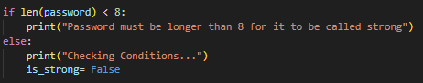

After which the program checks with the secondary conditions like **(Underscores ‘_’, Punctuations, and Digits),**

First, the program takes it to a condition that checks if the password entered has an upper-case letter or not, if not, the program returns an error **“Password must contain at least one Upper Case Letter”.**

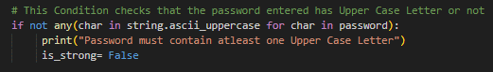

If yes, the program runs the digits condition and checks whether the password has a **Digit** or not, if not, the user is prompted by **“Password must have at least one Digit”**,

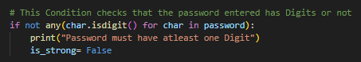

If yes, the program takes it to the next conditions and checks whether the password has a **Punctuation** or not, if not the program returns the error **“Password must have at least one Punctuation”**,

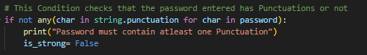

If yes finally the password is taken to check if it has an **Underscore** or not, if not the program returns an error **“Password must have at least one Underscore”.**

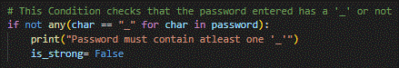

If all the conditions are passed the user is prompted by **“Your Password is Strong”.**

**Logic:**The program runs a ‘for’ loop with char which checks each character one by one in the User-entered Password, Example: When the Digits condition comes to check whether the Password has a digit or not so the for loop runs by checking if the first character of the Password is a digit or not, if not it runs to the second character of the Password and does it until it doesn’t find a digit to set the condition to ‘True’ if it doesn’t find any digit then it returns an error

**Link To Burhan GitHub Repository:**

[**https://github.com/Burhan-Ul-Haq/BanoQabil-3.0-Python-Course**](https://github.com/Burhan-Ul-Haq/BanoQabil-3.0-Python-Course)

**Link To Hanzala GitHub Repository:**

[**https://github.com/HanzalaR-web/BanoQabil-3.0-Python-Course**](https://github.com/HanzalaR-web/BanoQabil-3.0-Python-Course)